Program 2: Maven Project with Google Guava and Apache Commons-IO Dependencies
Procedure
Step 1: Create a Maven Project
mvn archetype:generate -DgroupId=com.example -DartifactId=MyMavenGuavaApp \
-DarchetypeArtifactId=maven-archetype-quickstart -DinteractiveMode=false
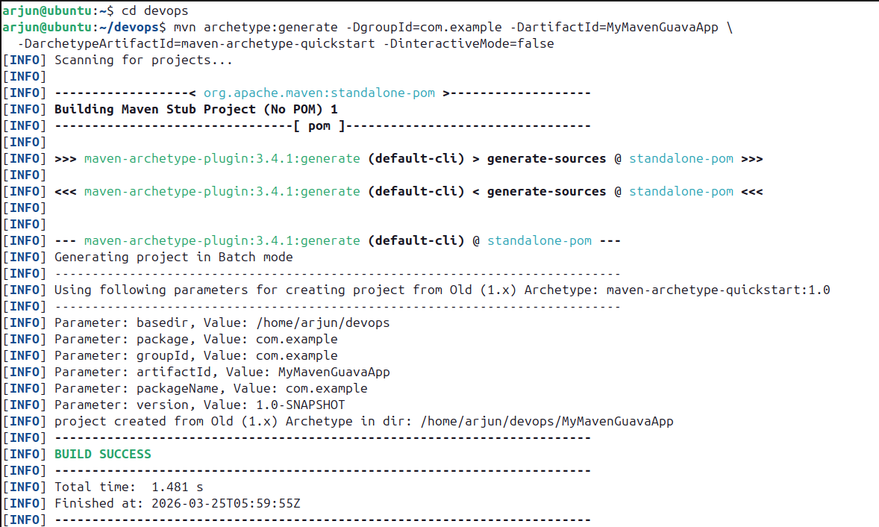

Step 2: Navigate to the Project Directory
cd MyMavenGuavaApp
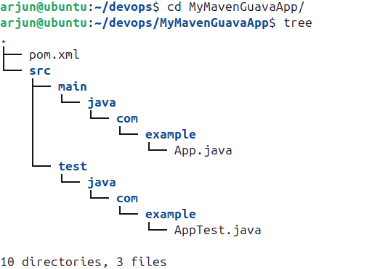
tree

Step 3: Edit pom.xml to Add Dependencies
gedit pom.xml

Add Google Guava and Commons-IO dependencies from https://mvnrepository.com under the <dependencies> section.
pom.xml
<project xmlns="http://maven.apache.org/POM/4.0.0"
xmlns:xsi="http://www.w3.org/2001/XMLSchema-instance"
xsi:schemaLocation="http://maven.apache.org/POM/4.0.0
http://maven.apache.org/maven-v4_0_0.xsd">
<modelVersion>4.0.0</modelVersion>
<groupId>com.example</groupId>
<artifactId>MyMavenGuavaApp</artifactId>
<packaging>jar</packaging>
<version>1.0-SNAPSHOT</version>
<name>MyMavenApp</name>
<url>http://maven.apache.org</url>
<properties>
<maven.compiler.source>11</maven.compiler.source>
<maven.compiler.target>11</maven.compiler.target>
</properties>
<dependencies>
<dependency>
<groupId>junit</groupId>
<artifactId>junit</artifactId>
<version>3.8.1</version>
<scope>test</scope>
</dependency>
<!-- Guava: Google core Java utilities -->
<dependency>
<groupId>com.google.guava</groupId>
<artifactId>guava</artifactId>
<version>33.5.0-jre</version>
<scope>compile</scope>
</dependency>
<!-- Commons IO: Apache file/IO operations -->
<dependency>
<groupId>commons-io</groupId>
<artifactId>commons-io</artifactId>
<version>2.21.0</version>
<scope>compile</scope>
</dependency>
</dependencies>
<build>
<plugins>
<plugin>
<groupId>org.apache.maven.plugins</groupId>
<artifactId>maven-compiler-plugin</artifactId>
<version>3.8.1</version>
<configuration>
<source>1.7</source>
<target>1.7</target>
</configuration>
</plugin>
<plugin>
<groupId>org.apache.maven.plugins</groupId>
<artifactId>maven-surefire-plugin</artifactId>
<version>2.22.2</version>
</plugin>
<plugin>
<groupId>org.apache.maven.plugins</groupId>
<artifactId>maven-jar-plugin</artifactId>
<version>3.1.0</version>
<configuration>
<archive>
<manifestEntries>
<Main-Class>com.example.App</Main-Class>
</manifestEntries>
</archive>
</configuration>
</plugin>
</plugins>
</build>
</project>
Step 4: Modify App.java
cd src/main/java/com/example/
gedit App.java
App.java
package com.example;

// Import FileUtils class from Apache Commons IO library
// Used to perform file operations like copying files
import org.apache.commons.io.FileUtils;

// Import File class to represent file and directory pathnames
import java.io.File;

// Import IOException to handle input-output errors
import java.io.IOException;

// Import ImmutableList from Google Guava library
// ImmutableList creates a list that cannot be modified after creation
import com.google.common.collect.ImmutableList;

public class App {
public static void main(String[] args) {

// Create an immutable list of strings (fruits)
// This list cannot be changed (no add/remove allowed)
ImmutableList<String> fruits = ImmutableList.of("Apple", "Banana", "Cherry");

// Print the list of fruits to the console
System.out.println(fruits);

// Create a File object representing the source file
File sourceFile = new File("source.txt");

// Create a File object representing the destination file
File destFile = new File("destination.txt");

try {
// Copy the contents of source.txt to destination.txt
// Using Apache Commons IO FileUtils class
FileUtils.copyFile(sourceFile, destFile);

// Print success message if file is copied
System.out.println("File copied successfully!");
}
catch (IOException e) {
// Print error message if any exception occurs
System.err.println("Error occurred while copying file: " + e.getMessage());
}
}
}

Step 5: Create source.txt
gedit source.txt

Content of source.txt:
Hello DevOps
Hello World
Hello println

Step 6: Compile the Project
mvn clean install
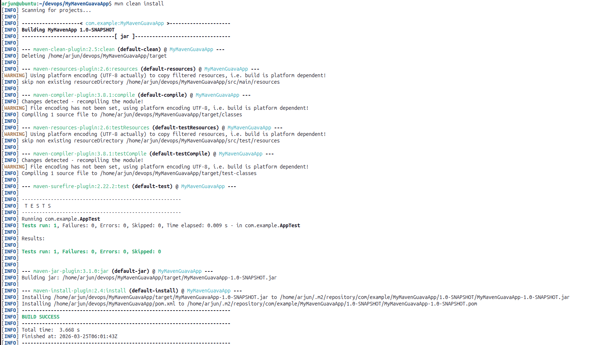

Step 7: Run the Application
mvn exec:java -Dexec.mainClass="com.example.App"
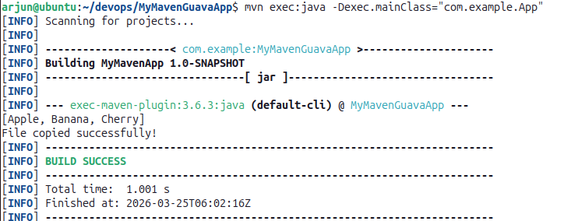

Step 8: Verify destination.txt
gedit destination.txt
